Mailman Max



In this project you will make a main postal sorting office. It will need to sort letters so that they can be put into vans going to the right local sorting offices.

The postcode is a great way to work out the next sorting office a letter should go to, so you’ll use that.

You’ll train the computer to recognise what the different codes at the start of a postcode look like when they are hand-written, and use that to sort letters.



This project worksheet is licensed under a Creative Commons Attribution Non-Commercial Share-Alike License

http://creativecommons.org/licenses/by-nc-sa/4.0/

1. Go to [https://machinelearningforkids.co.uk](https://machinelearningforkids.co.uk/) in a web browser
2. Click on “**Get started**”
3. Click on “**Log In**” and type in your username and password  
   *If you don’t have a username, ask your teacher or group leader to create one for you.  
   If you can’t remember your password, ask your teacher or group leader to reset it for you.*
4. Click on “**Projects**” on the top menu bar
5. Click the **“+ Add a new project**” button.

1. Name your project “Mailman Max” and set it to learn how to recognise “**images**”.   
   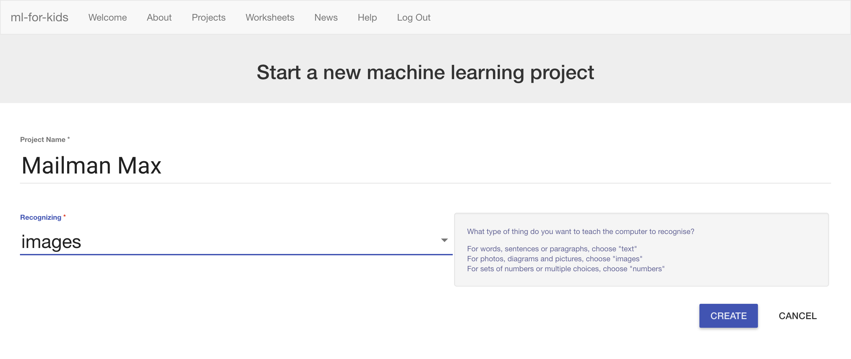
2. Click the “**Create**” button

1. You should see “**Mailman Max**” in the list of your projects. Click it.
2. Click the “**Train**” button  
   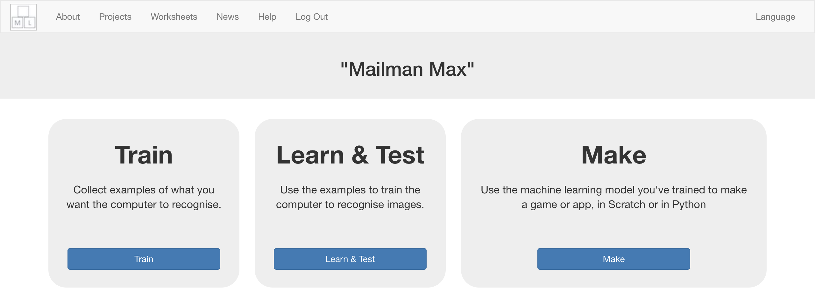
3. Click the “**Add new label**” button, and create a label called “Oxford”  
   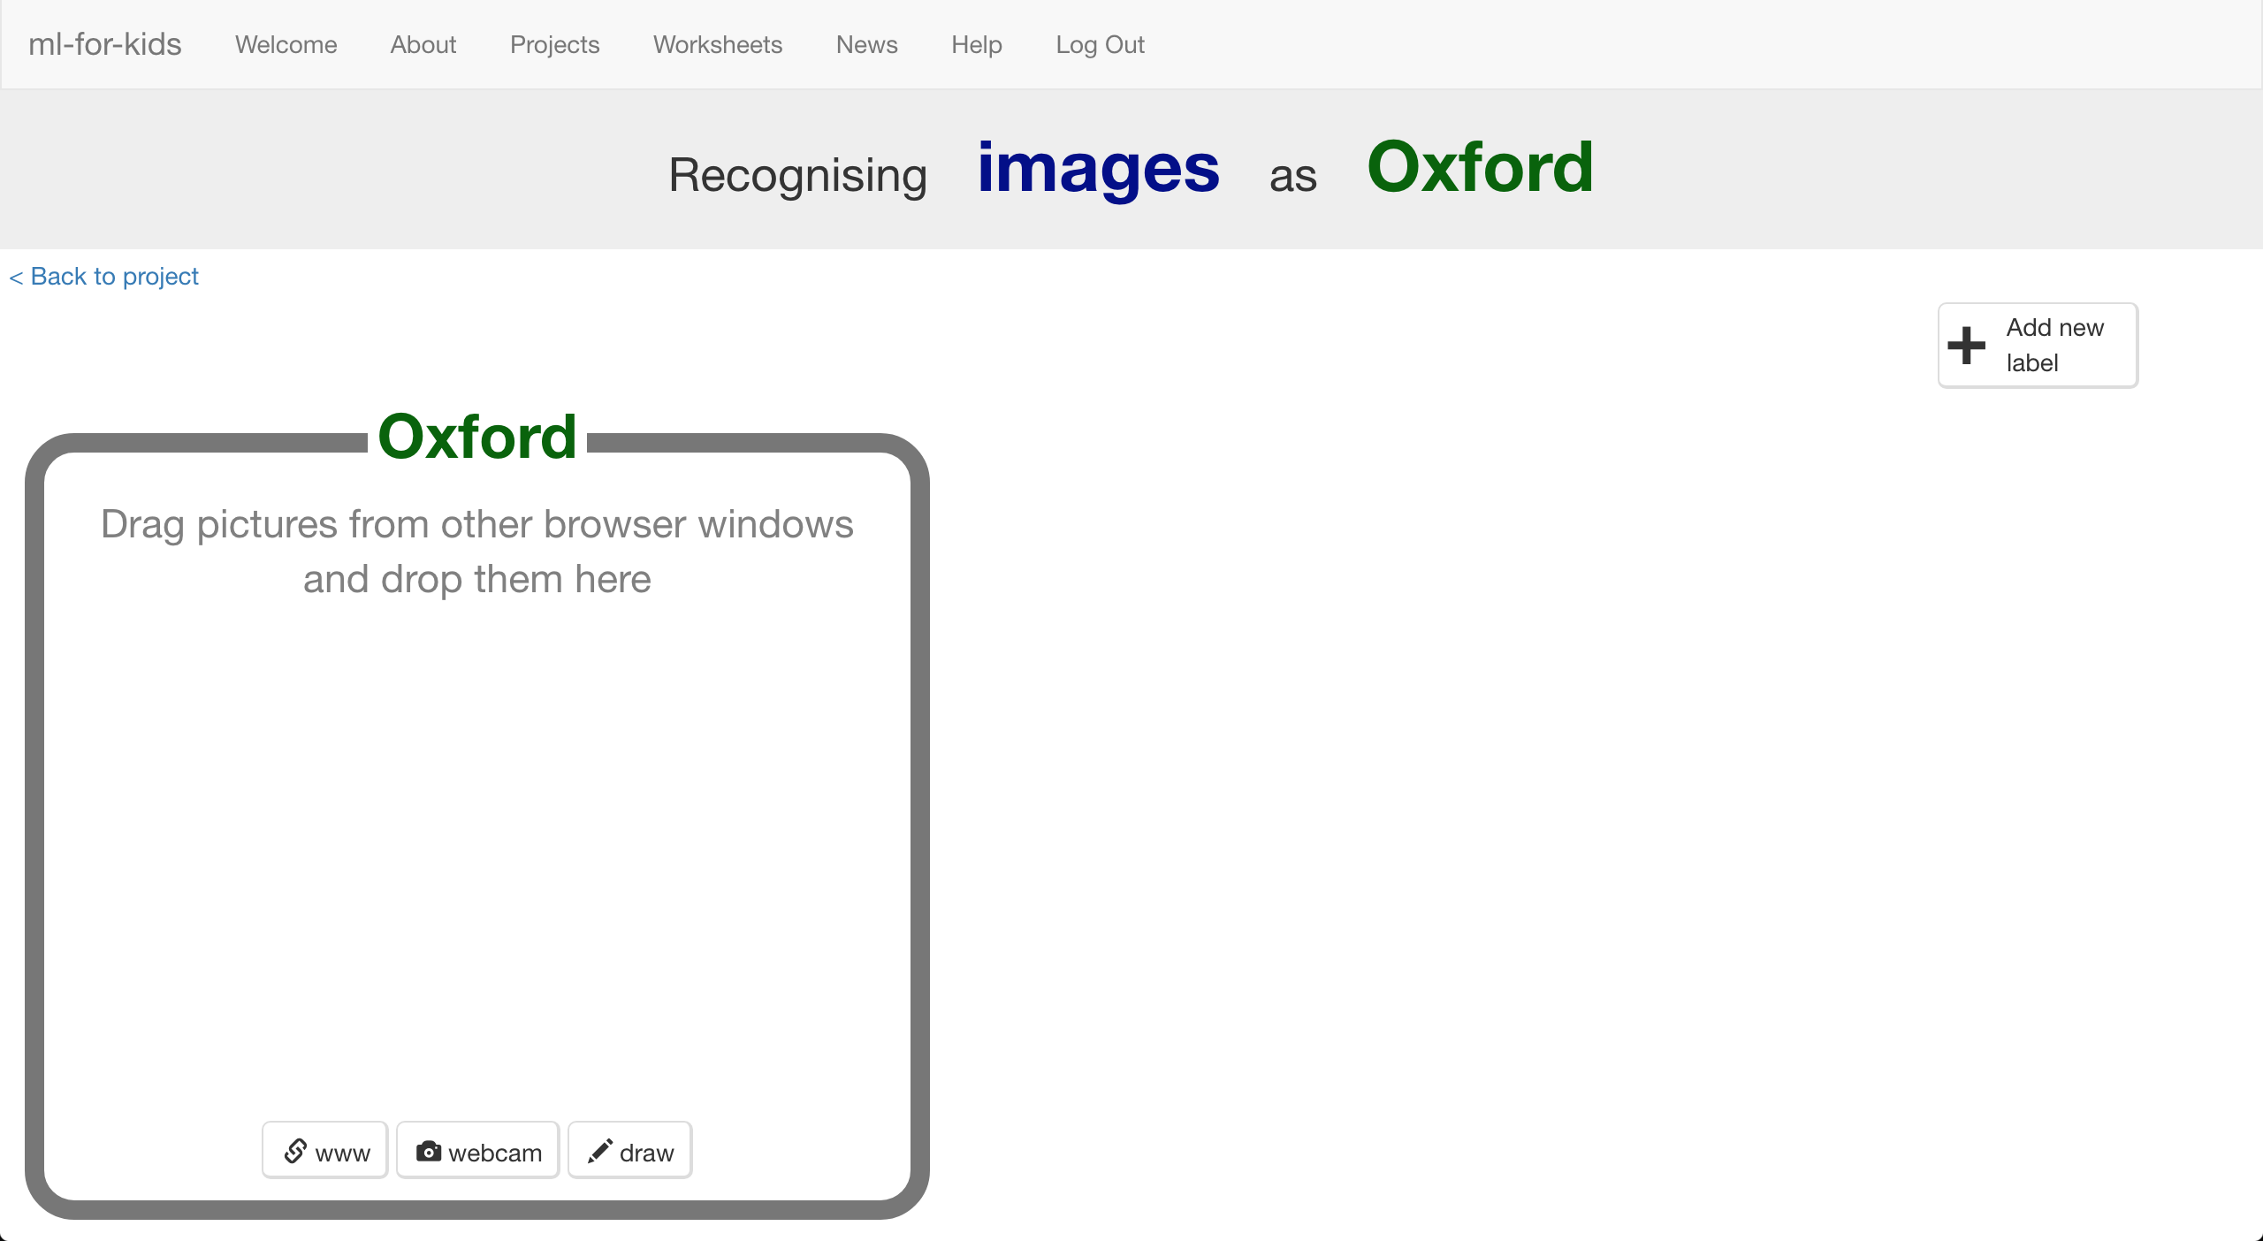
4. Click the “**draw**” button in the “Oxford” bucket  
   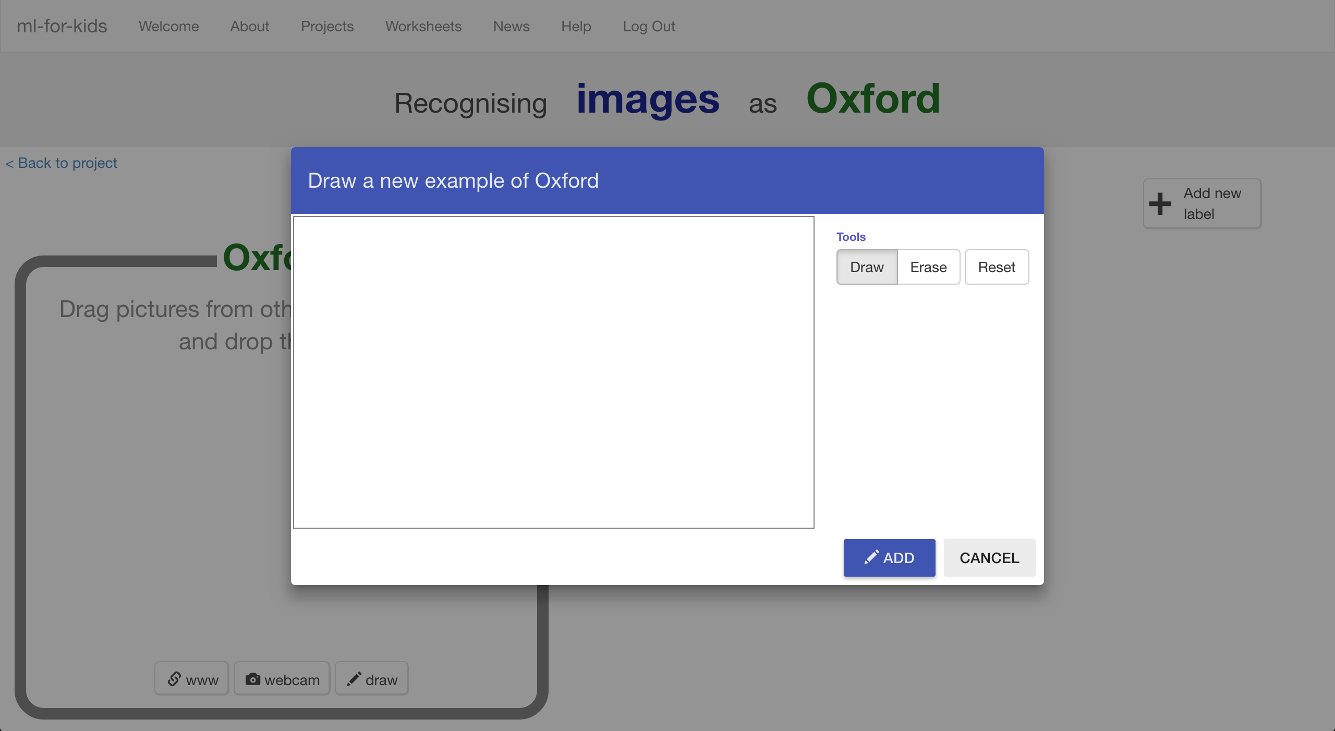
5. Use your mouse to write “**OX**” in the empty box.   
   *OX is the start for postcodes in the Oxford area.   
   Try to use all the space in the box, like in the picture below.  
   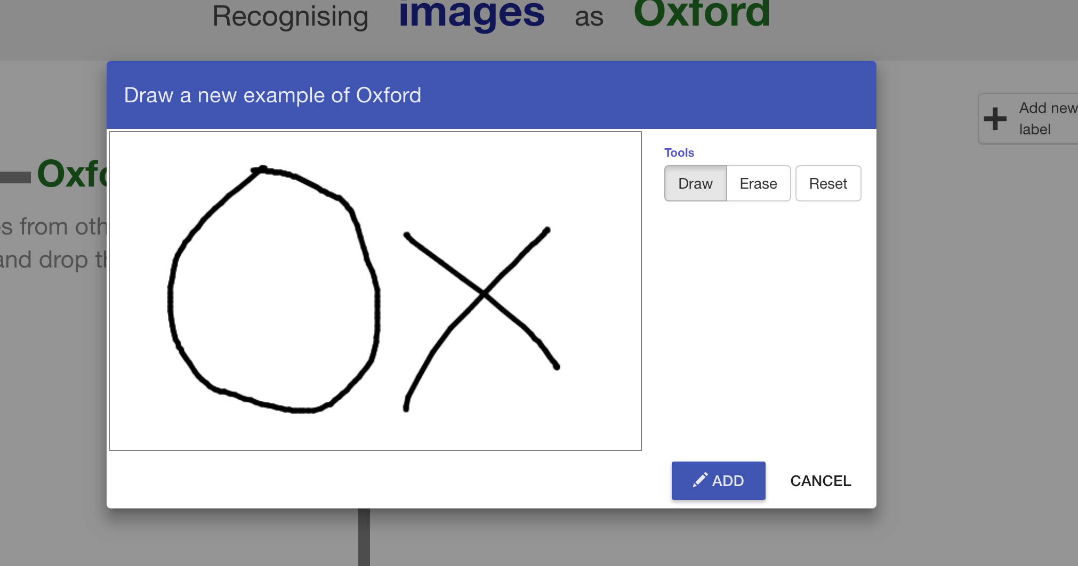*
6. Click “**ADD**”
7. Click “**Draw**” again, and draw another “OX”  
   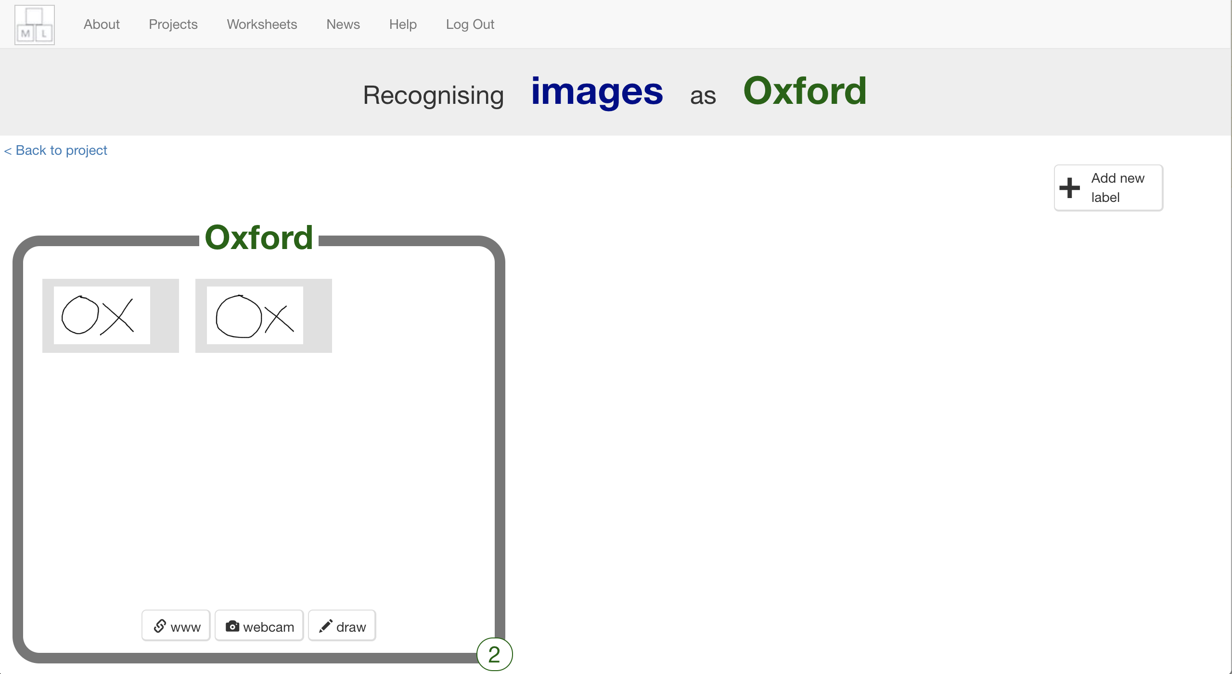

1. Repeat until you’ve got **10** examples of “OX”
2. Click “**Add new label**” again, and create one called “Guildford”  
   
3. Use the “**Draw**” button in the “Guildford” bucket to draw 10 “GU” for postcodes in the Guildford area  
   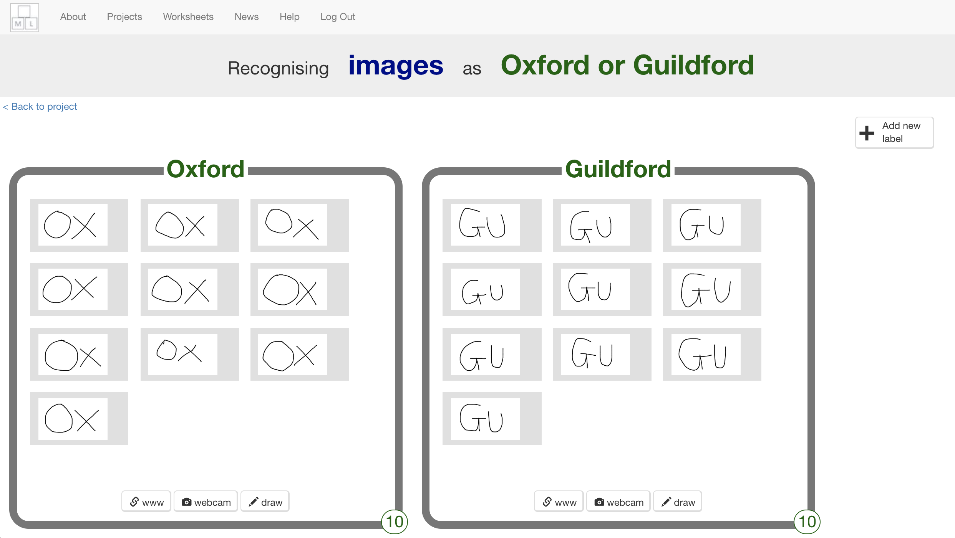
4. Click “**Add new label**” again, and create one called “Southampton”
5. Draw 10 “SO” examples for postcodes in the Southampton area  
   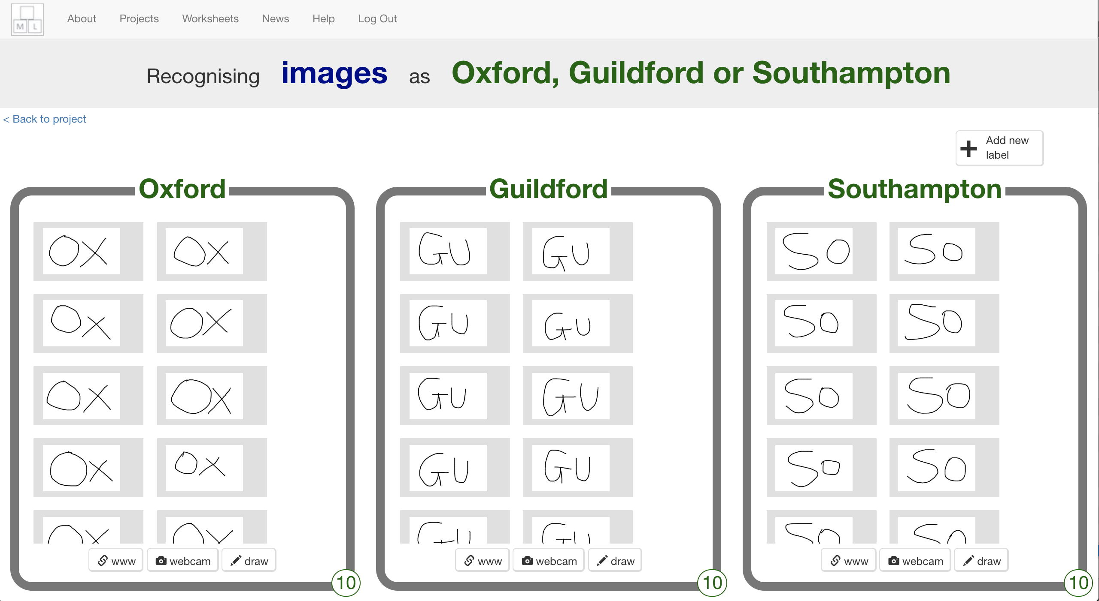
6. Click on the “**< Back to project**” link
7. Click the “**Learn & Test**” button
8. Click the “**Train new machine learning model**” button  
   *It might take a few minutes for this to finish. You can carry on and get your Scratch project ready, but it won’t work until the training finishes.*  
   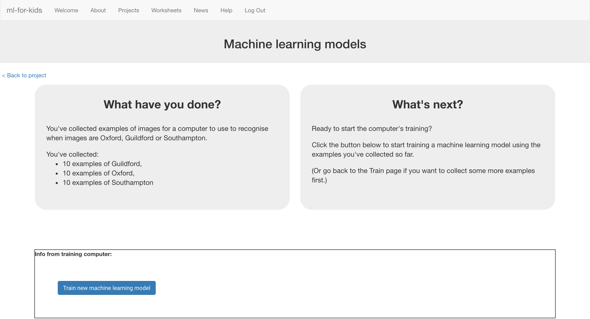
9. Click the “**< Back to project**” link
10. Click the “**Make**” button
11. Click the “**Scratch 3**” button  
    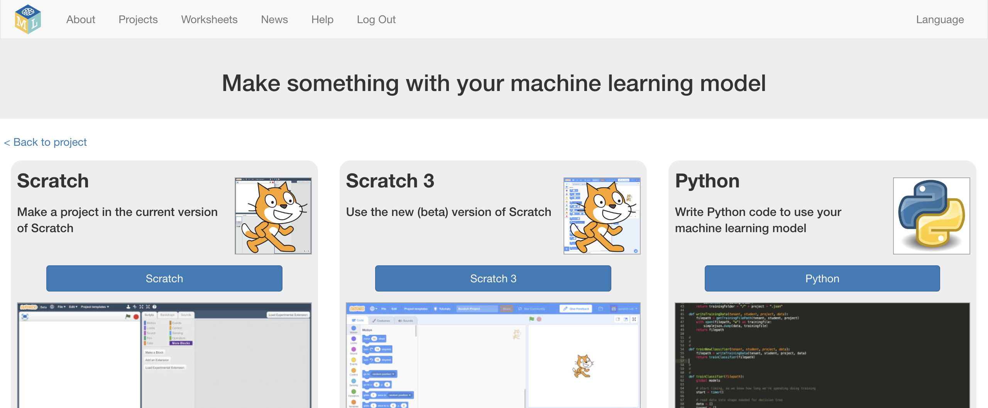
12. Click on “**Open in Scratch 3**”

**What have you done so far?**

You’ve started to train a computer to recognise pictures of handwriting as being the start of postcodes for the Oxford, Guildford, or Southampton area. You are doing it by collecting examples of your handwriting. These examples are being used to train a machine learning “model”.

This is called “supervised learning” because of the way that you are supervising the computer’s training.

The computer will learn from patterns in the shapes of each of the examples you’ve drawn. This will be used to be able to recognise the postcodes we’ll write on the envelopes to be sorted.

1. Click “**Project templates**”  
   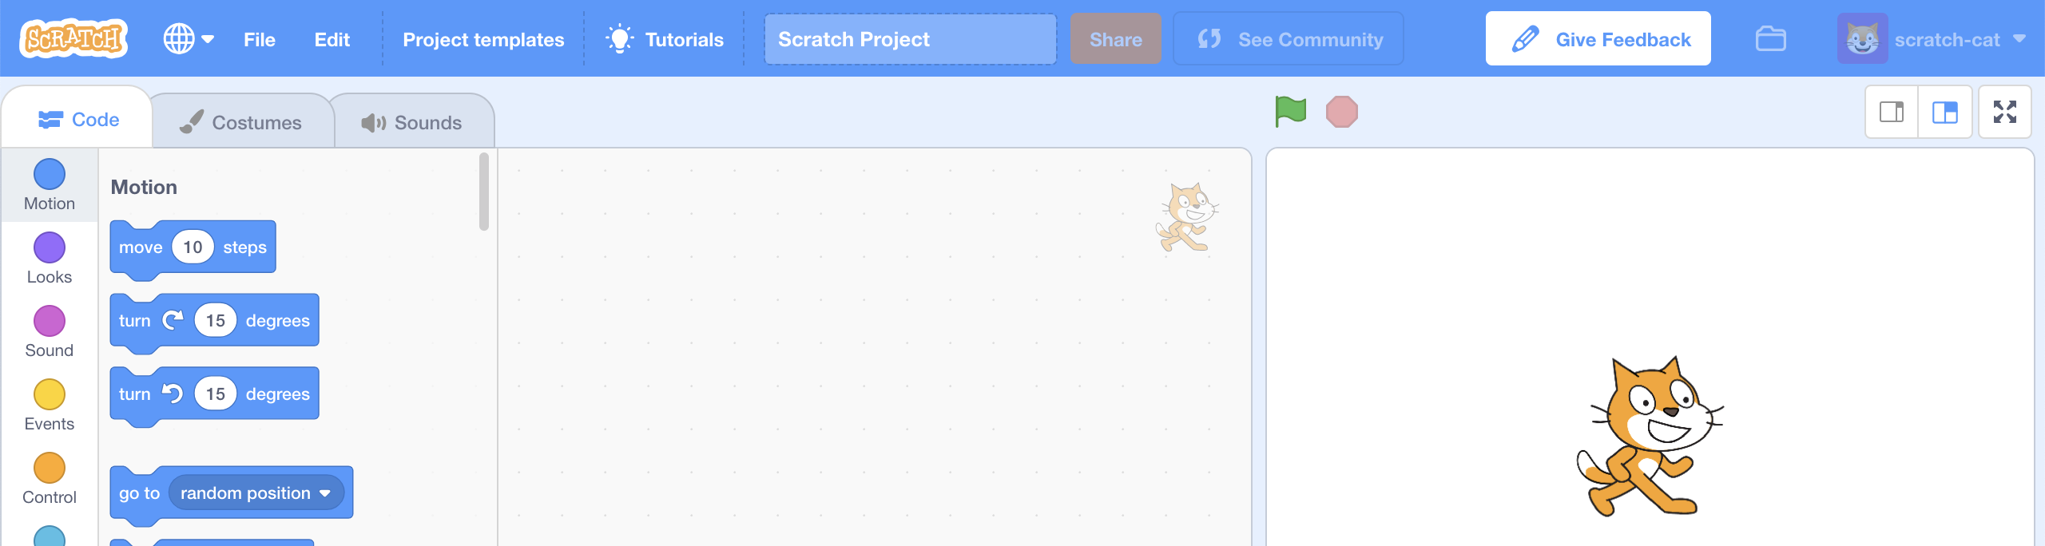
2. Click on the “**Mailman Max**” project template   
   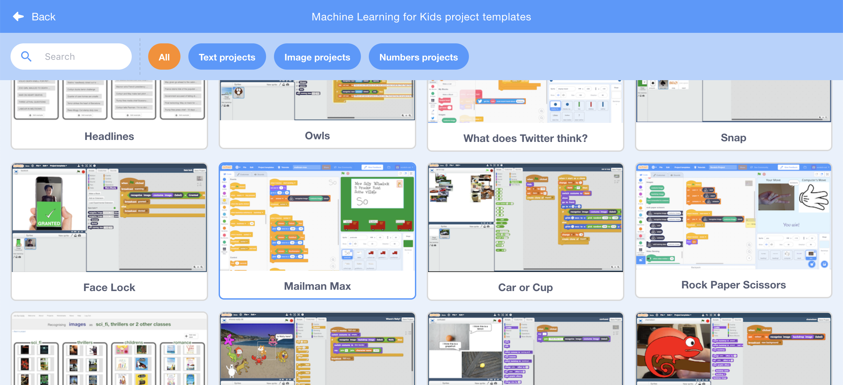
3. Find the “**when green flag clicked**” script on the “postcode” sprite  
   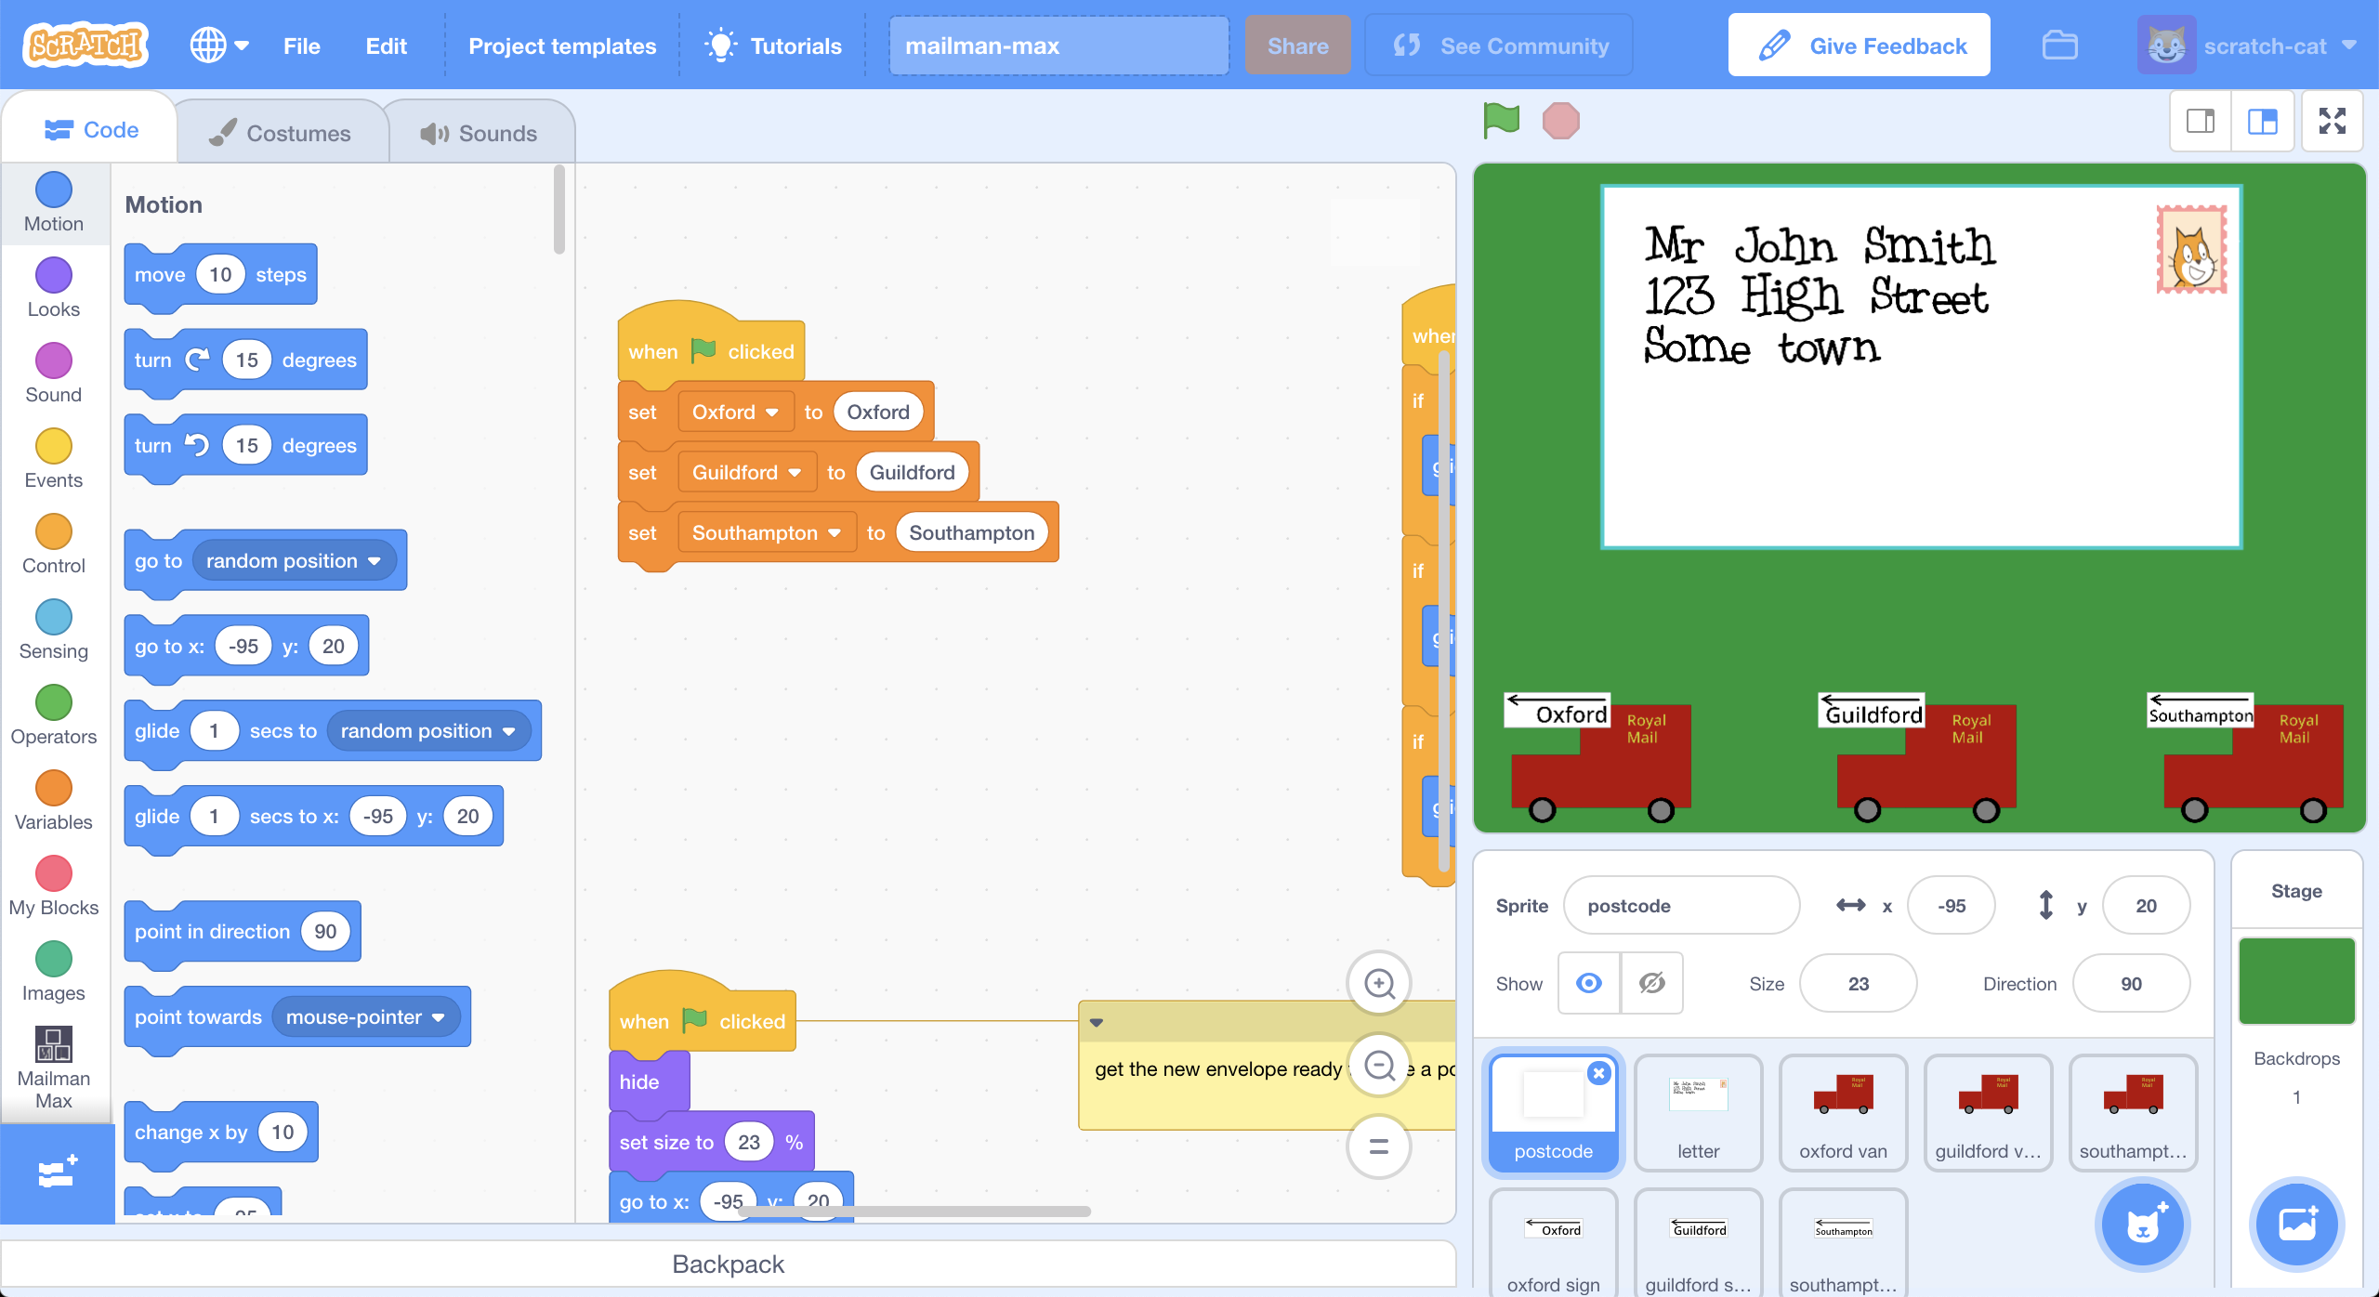
4. Copy your town name blocks into the script  
   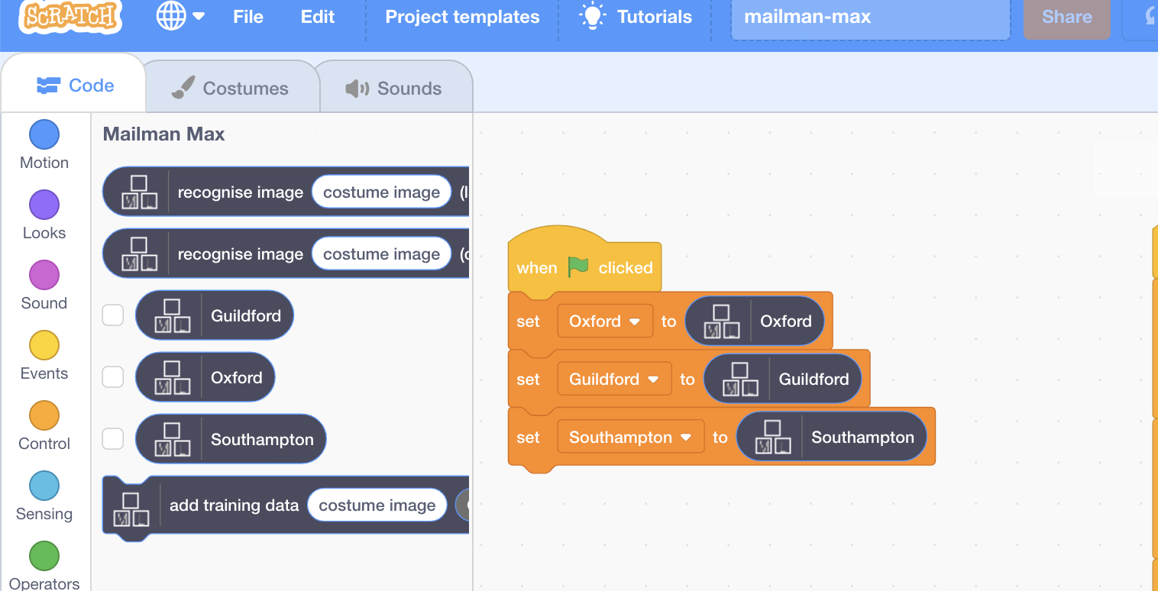
5. Add this script to recognise postcodes you’ll write on the envelope  
   *This is still on the “postcode” sprite*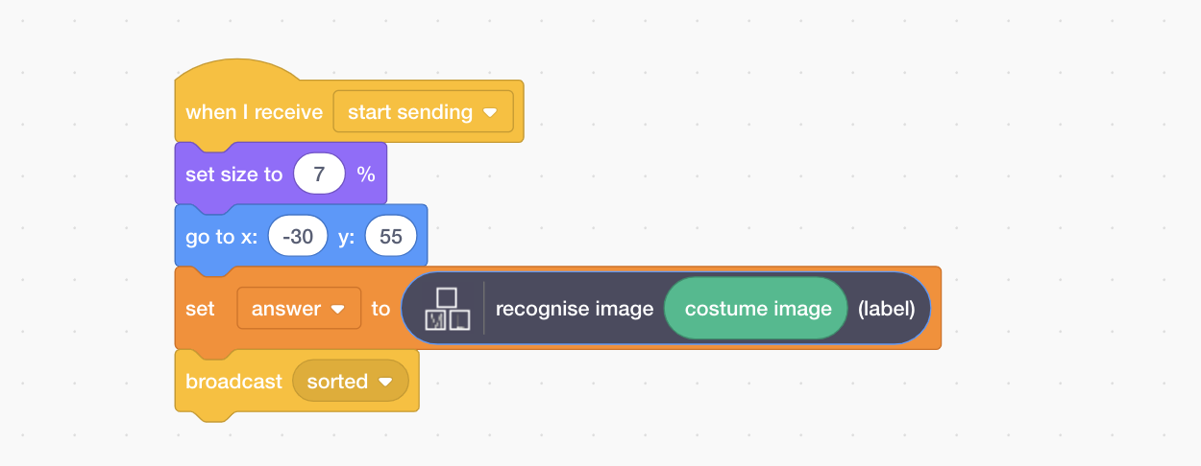
6. Save your project  
   *Click “****File****” -> “****Download to your computer****”**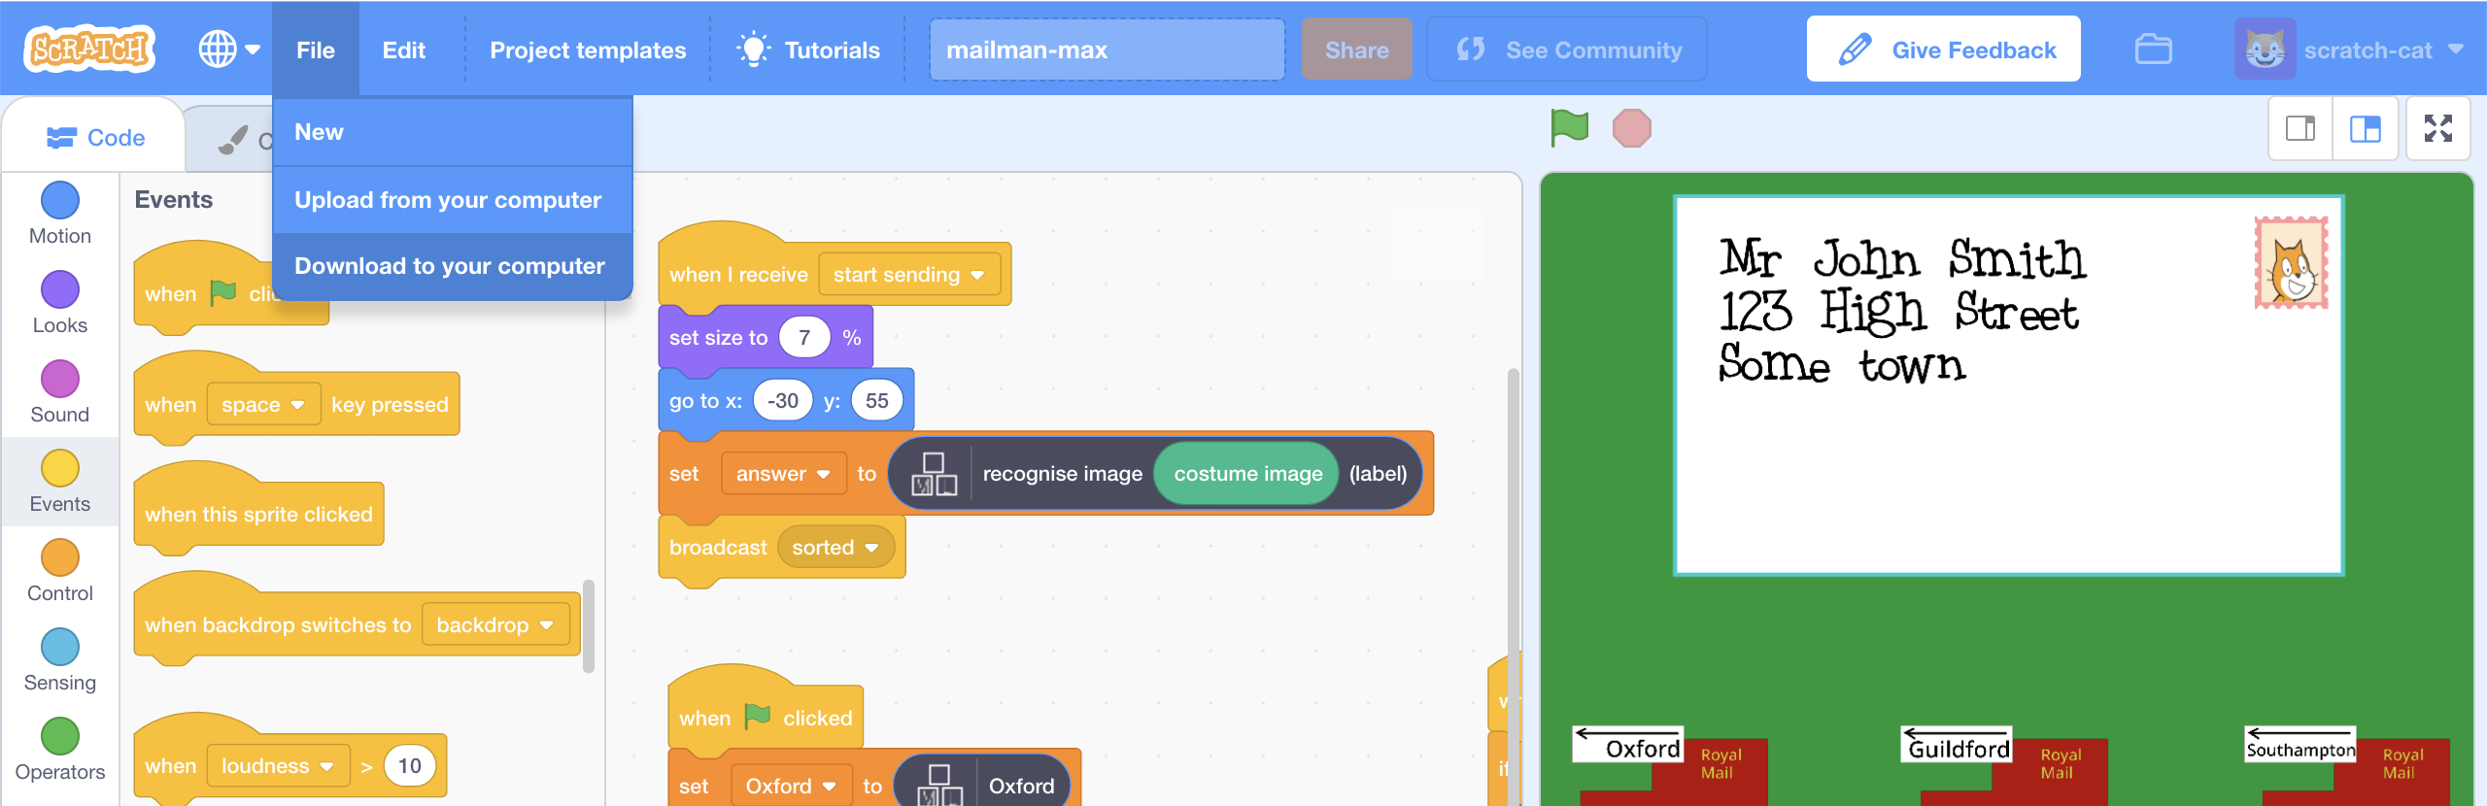*
7. Click the **Green Flag**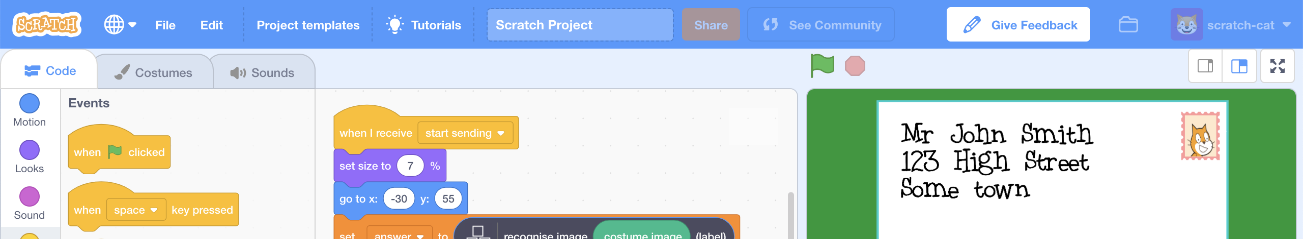
8. Still on the “**postcode**” sprite, click on “**Costumes**”  
   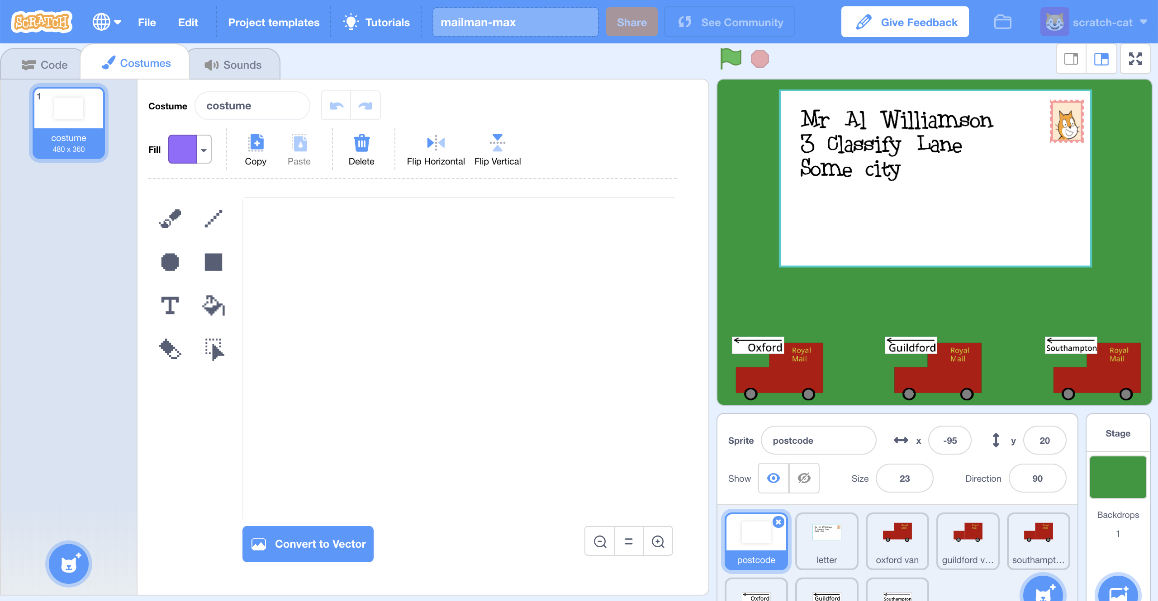
9. Start a new costume by clicking on “**Paint**”  
   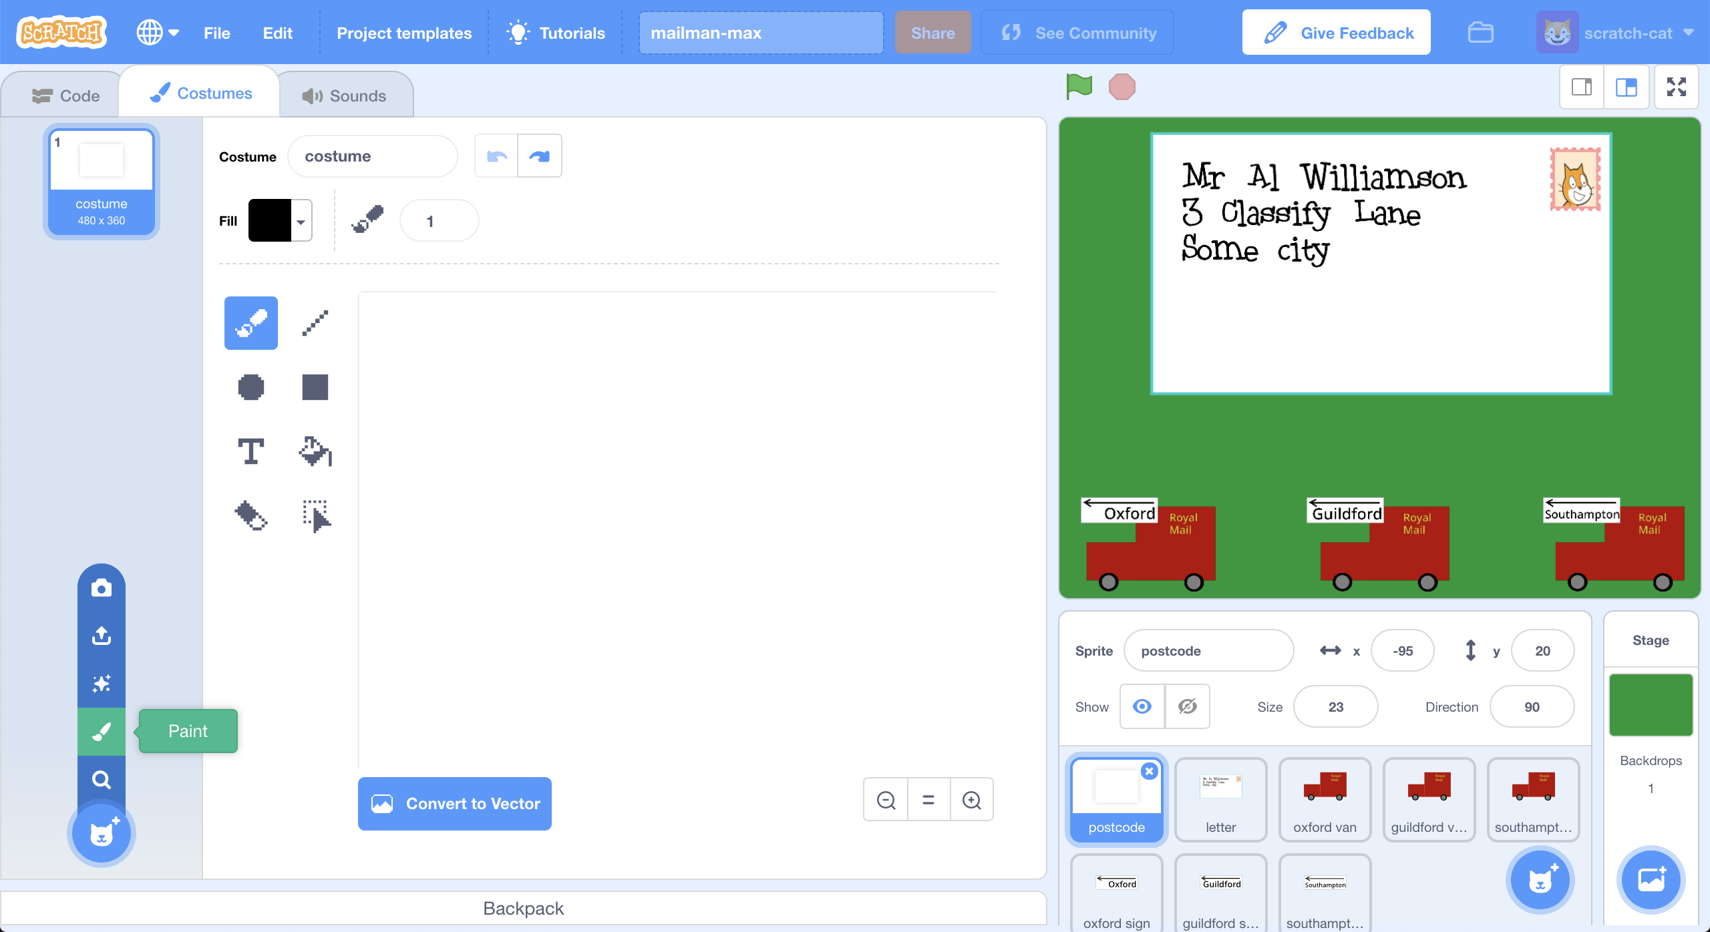
10. Update the settings to use a **20**-pixel **black** paint **brush**  
    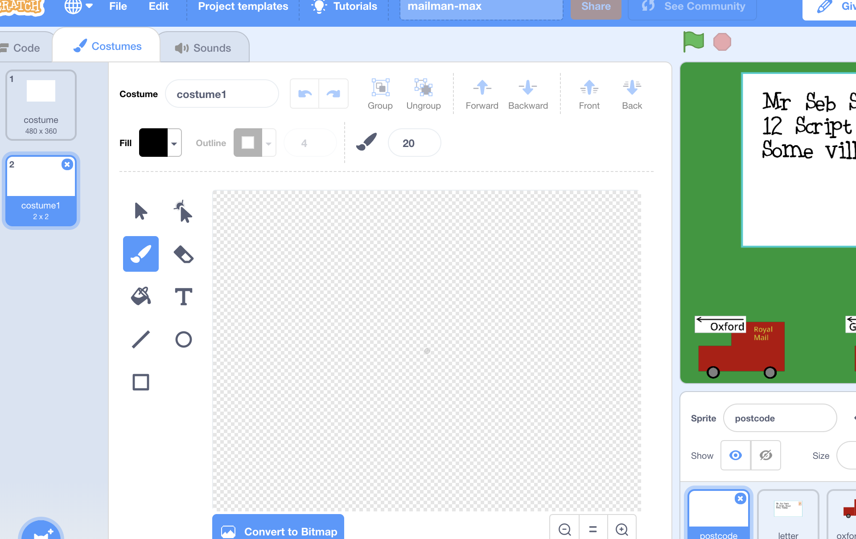
11. Write the first two letters of a postcode using the paintbrush tool.  
    *Fill the space, like you did with the training examples.  
    You should also see it appear in the envelope in the right place.  
    If it looks too big in the envelope, click the Green Flag again.*  
    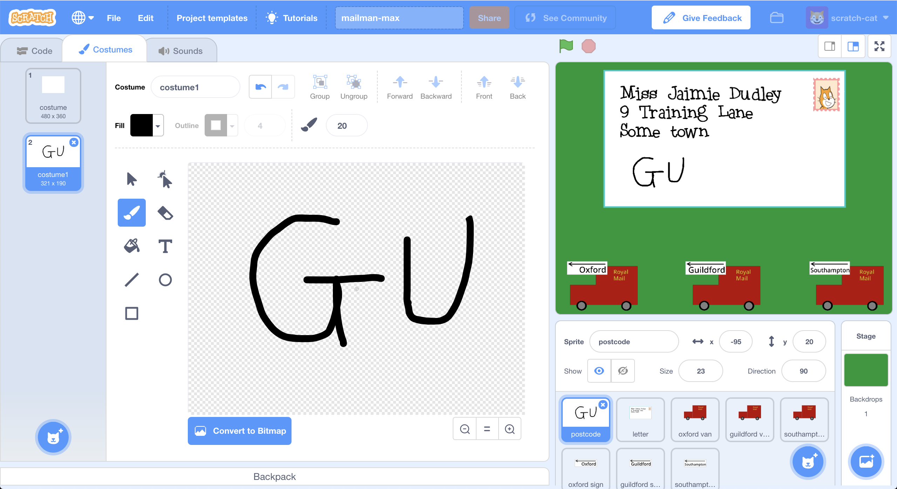
12. Click the full-screen button, and then click on the stamp  
    *You should see the letter shrink. Then the computer will try to recognise the postcode letters you’ve written. Once it thinks it has the answer, the envelope will move to the van for the correct sorting office.*  
    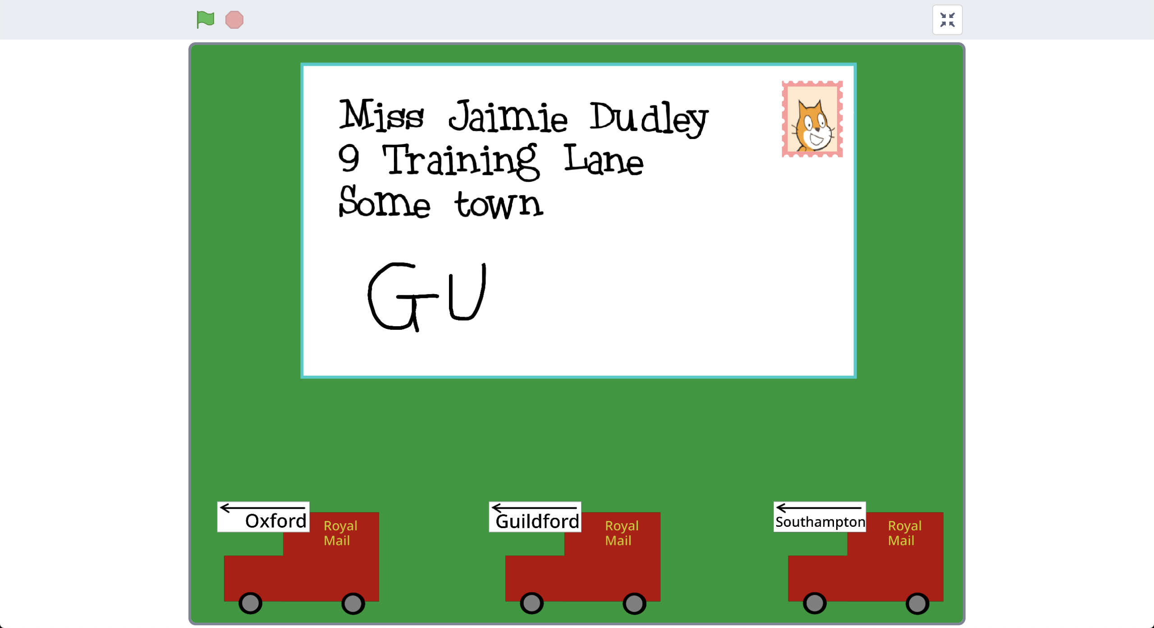
13. Did it get it right?  
    *If not, you might need to add some more examples, and train a new machine learning model (steps 21-22) with them.*
14. Repeat steps 35-38 to try it again with a different postcode  
    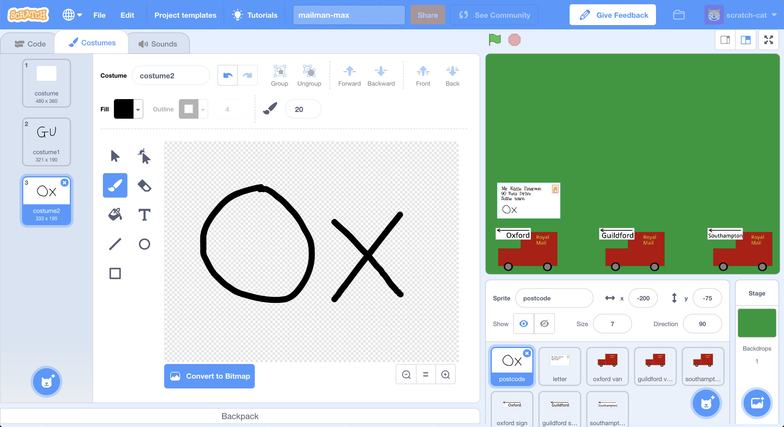

**What have you done?**

You’ve trained a machine learning model to be able to do handwriting recognition. This is called “optical character recognition” or “OCR” for short.

You did that by collecting examples of handwriting, to train the computer to be able to recognise it.

You built a small and simple example, using just the first two letters for just three postcode areas.

Imagine doing the same thing for every postcode area in the country. You’d have to create a lot more training buckets to cover the 120 postcode areas in the UK. And you’d need to collect thousands of training examples, with lots of different people’s handwriting, so that the computer could get really good at recognising them.

That is how large postal sorting offices sort our letters in real life.

**Ideas and Extensions**

Now that you’ve finished, why not give one of these ideas a try?

Or come up with one of your own?

**Try someone else’s handwriting**

You’ve trained the computer to recognise how you write the postcode letters, but would it be able to recognise someone else’s?

Ask a friend to test it and see if it works.

If it doesn’t, you’ll need to get some examples of their writing to add to your training data. The more people you can get training examples from, the better the computer will be at recognising a variety of handwriting styles.

**Try more of the postcode**

We made it easier for the computer by only giving it the first two letters.

But how can we get it to recognise something like “OX1 2JD” as being a postcode in the Oxford area?

If you collect a variety of different training examples of actual full postcodes (not just the first two letters) you should be able to train it to recognise them. That will probably need more than 10 examples!